Hong Kong Exchanges and Clearing Limited and The Stock Exchange of Hong Kong Limited take no responsibility for the contents of this announcement, make no representation as to its accuracy or completeness and expressly disclaim any liability whatsoever for any loss howsoever arising from or in reliance upon the whole or any part of the contents of this announcement.

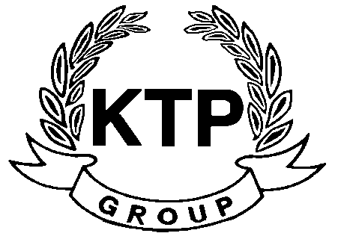
KTP Holdings Limited
港台集團有限公司*
(Incorporated in Bermuda with limited liability)
(Stock Code: 645)

ANNOUNCEMENT PURSUANT TO RULE 13.09 OF THE LISTING RULES (UNUSUAL PRICE AND TRADING VOLUME MOVEMENT)
AND RESUMPTION OF TRADING

This announcement is made pursuant to Rule 13.09 of the Listing Rules.

The Board noted that there was an increase in trading volume and price of the shares of the Company yesterday and wishes to state that it had been advised by the Controlling Shareholder that he had recently received indications from various independent third parties regarding their interests in purchasing all or part of his shareholding in the Company. It is uncertain whether any proposal will be acceptable to the Controlling Shareholder and there is no assurance whether subsequent discussions and / or negotiations, if any, may result in a change in control of the Company or lead to a general offer for the shares of the Company. Save for the above, the Board confirms that it is not aware of any reasons for such increases in trading volume and price of the shares of the Company.

The Board also wishes to inform the shareholders of the Company and potential investors that, save as aforesaid, there are no negotiations or agreements relating to intended acquisitions or realisations which are discloseable under Rule 13.23 of the Listing Rules, neither is the Board aware of any matter discloseable under the general obligation imposed by Rule 13.09 of the Listing Rules, which is or may be of a price-sensitive nature.

At the request of the Company, trading in the shares of the Company was suspended with effect from 9:30 a.m. on 5th August 2010 pending the release of this announcement. Application has been made by the Company to the Stock Exchange for the resumption of trading in the shares of the Company with effect from 9:30 a.m. on 6th August 2010.

This announcement is made pursuant to Rule 13.09 of the Rules Governing the Listing of the Securities (the “Listing Rules”) on The Stock Exchange of Hong Kong Limited (the “Stock Exchange”).

The board of directors (the “Board”) of KTP Holdings Limited (the “Company”) noted that there was an increase in trading volume and price of the shares of the Company yesterday and wishes to state that it had been advised by the controlling shareholder (the “Controlling Shareholder”) of the Company, Mr. Lee Chi Keung, Russell, who is interested in approximately 59.76% of the total issued shares of the Company, that he had recently received indications from various independent third parties regarding their interests in purchasing all or part of his shareholding in the Company. It is expected that any proposal from such independent third parties will take some time to evaluate. It is uncertain whether any proposal will be acceptable to the Controlling Shareholder and there is no assurance whether subsequent discussions and / or negotiations, if any, may result in a change in control of the Company or lead to a general offer for the shares of the Company. Save for the above, the Board confirms that it is not aware of any reasons for such increases in trading volume and price of the shares of the Company.

The Board confirms that, save as aforesaid, there are no negotiations or agreements relating to intended acquisitions or realisations which are discloseable under Rule 13.23 of the Listing Rules, neither is the Board aware of any matter discloseable under the general obligation imposed by Rule 13.09 of the Listing Rules, which is or may be of a price-sensitive nature.

Shareholders of the Company and other investors are advised to exercise caution when dealing in the shares of the Company.

At the request of the Company, trading in the shares of the Company was suspended with effect from 9:30 a.m. on 5th August 2010 pending the release of this announcement. Application has been made by the Company to the Stock Exchange for the resumption of trading in the shares of the Company with effect from 9:30 a.m. on 6th August 2010.

By Order of the Board
KTP Holdings Limited
Lee Chi Keung, Russell
Chairman
Hong Kong, 5th August 2010

As at the date of this announcement, the executive directors of the Company are Mr. Lee Chi Keung, Russell (Chairman), Ms. Yu Mee See, Maria and the independent non-executive directors are Mr. Ng Wai Hung, Mr. Lee Siu Leung and Mr. Yuen Sik Ming.

*For identification purpose only

